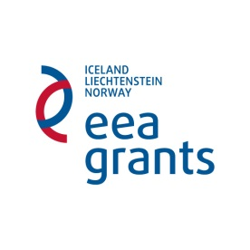
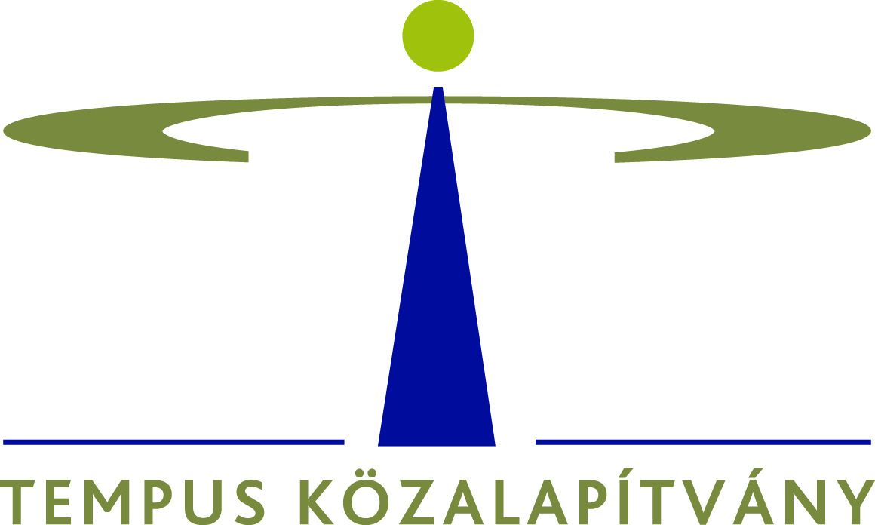

EEA Financial Mechanism 2009-2014

Scholarship Programme (HU08)

Inter-institutional Cooperation Projects between Higher Education Institutions (M4)

Interim and Final Report Form for the Beneficiary

Intensive Programmes

Grant agreement reference number: Click here to write text

Project number: Click here to write text

<<< Please select the relevant option >>>

General instructions

- This report is considered as your request for the second pre-financing from the grant.
- In so far as the interim report demonstrates that the beneficiary has spent at least 60% of the amount of first pre-financing payment, the interim report shall be considered as a request for the second pre-financing payment.
- You should consult with any existing Guidelines provided by the Programme Operator before filling in the reporting forms.
- The interim report is submitted by the Beneficiary on behalf of all the organisations participating in the project. The declaration on the following page confirms that a process of consultation and approval has been carried out throughout the partnership. It is therefore important that the required information should be collected in good time before the deadline for submission of the Interim Report.
- A hard copy of the interim report must be sent to the Programme Operator any time after the start of the project when 60% of the first instalment has been used but no later than 31 July 2016 to:

Tempus Közalapítvány
Felsőoktatási csoport
1438 Budapest 70. Pf. 508.

- An electronic version of the final report should be sent to egtalaposztondij@tpf.hu.
- Please attach to your Report one copy of all project products and results (if any). If you refer to web sites, passwords should be given for all private areas.
- You are strongly advised to send your Report by registered post to ensure a record of postage. Additionally, you are advised to keep a copy of the full report, including any annexes.

DECLARATION BY BENEFICIARY

Grant Agreement number: Click here to write text

I, the undersigned, hereby declare that the information contained in this interim / final report is accurate and in accordance with the facts. This information has been checked and approved by the partners involved in the activities set out in this report.
I herewith request the second pre-financing from the grant, in accordance with the terms of the Grant Agreement.

Signed in: Click here to write text Date, place: Click here to write text

Signature of the Beneficiary's legal representative

Seal/stamp of the organisation
Name and function in capital letters

I. PROJECT IDENTIFICATION, DESCRIPTION OF PROJECT ACTIVITIES, PRODUCTS AND RESULTS

Project title | Click here to write text
Project duration | Click here to write text
Report type | Click here to write text
Period covered by the report | Click here to write text
Subject area and code | Click here to write text
Location of the IP | Click here to write text
Start date of the IP | Click here to write text
End date of the IP | Click here to write text

II. LIST OF ALL PARTNERS (INCLUDING PROJECT PROMOTER) WHO TAKE PART IN THE PROJECT

 | Erasmus ID Code (if applicable) | Full name of institution
Project Promoter | Click here to write text | Click here to write text
Partner 1. | Click here to write text | Click here to write text
Partner 2. | Click here to write text | Click here to write text

III. SUMMARY OF THE ACTIVITIES ALREADY UNDERTAKEN

List of activities

WP name | Task name | Activities undertaken | Start date (dd/mm/yyy) | Finish date (dd/mm/yyy) | Duration | Lead partner, other partners involved in the activities undertaken

IV. OVERALL DESCRIPTION OF THE ACTIVITIES

Please provide a comprehensive description, which gives a full account of the activities. Summarise under each heading (if applicable) the major divergence from the initial project plan and give the reasons for the changes. Provide an overview of the main difficulties encountered during the eligibility period, if any.

The description should cover the following:

IV.1. Objectives, Organisational aspects, Outputs
Objectives
- What are / were the aims and objectives of the IP? What means will be / were used to monitor their success or failure?
- How does / did the IP tie in with the existing teaching programmes of the participating institutions and explain what you considered to be innovative about the IP (in relation to each of the participating countries if the situation is different in each of them), namely in relation to defining or building a European dimension).
- To what extent does / did the IP present a strong multidisciplinary approach, fostering the interaction of students from different academic disciplines?
- Please describe the pedagogical and didactical approaches which were applied during the programme.

Organisational aspects
- The organisational approach and structure developed within the partnership to manage the project: describe the role(s) of individual partners (including any non-participation), organisation of the work and the way transnational cooperation took place. Please indicate also if any other organisations/contacts were involved.
- Are there any changes in the partnership?
- How will be / were the selection of students and teachers made?
- Do / Did you include disadvantaged and/or students and teachers with disabilities in the project?
- What is / was your approach for the transparent distribution of the amounts which the IP received for subsistence and travel costs? Do / Did you organise accommodation and/or meals centrally? (if applicable)
- Is / were there any risk/problem during the implementation? Please, describe how will / did you solve that problems. Please mention any related changes to the implementation.

Outputs
Please list all products/publications of the project already prepared (e.g.web-based exercises, multimedia products, websites etc.) Specify the nature, volume, structure, content and language used (where applicable).
Please provide a copy of each product in the envisaged form (hard copy or electronic copy) attached to the interim/final report. If you name a website please provide free entrance e.g. by preparing a suitable password for the Programme Operator.

Product 1 | Carrying out / divergence? (Explanation if applicable) | Remarks
Title

Media

Result type / No of Copies

Languages

Qualitative Description

(Add tables if necessary)

- On which basis (exam, presentation, activity during the IP, etc.) will / did the assessment of the students’ achievement take place?
- What are / were the expected learning outcomes? What kind of transversal competences will be / were transmitted within the IP?
- How will / did the studies be undertaken within the IP recognised in the curricula of the participating students by their home institutions? Do / Did you award ECTS (or otherwise equivalent) credits? If so, how many ECTS points will be/ were awarded? Any additional benefits and/or spin-offs of the project? (e.g. a curriculum development project or thematic network, research collaboration, etc.?)

IV.2. Evaluation and Dissemination

Evaluation and Dissemination
- What tools and criteria do / did you use to monitor and evaluate the appropriateness and effectiveness of your work (process and results)? Who does / did the evaluation? Which activities have you already undertaken concerning the dissemination of project objectives and results? Which tools do / did you use to disseminate outputs to a closer and wider audience? Please specify the target group you plan/ned to reach. Do you plan to extend the project partnership beyond the period of support from EEA Grants?

Further questions to the Final Report
1. Summary of the project results
Please summarize the project results which have been implemented. This shall be a stand-alone text suitable for publication at http://eeagrants.org/project-portal.

Please answer these questions in one-one paragraph, the whole text have to be maximum 2500 characters including spaces.

- Why was the project needed (background/context), and to what extent was the project’s objective achieved (the longer-term goal / sustainable change that the project was aiming for)?
- What did you produce or deliver in order to achieve the planned results? (Which outputs were delivered resulting from the main activities financed by the project?)
- What was actually achieved/which changes occurred for the main beneficiaries of the project? (Describe the project’s outcome, include facts and figures.

2. Summary of cooperation with partner(s)
1. How was the cooperation established? How did the project contribute to strengthening bilateral relations? Will the cooperation with the donor partner(s) continue after the project is completed?

- Briefly describe the main achievements on a bilateral level with partners (e.g. in the form of shared results, improved knowledge and understanding, or wide effects).
- Did bilateral funds contribute to strengthened bilateral relations at the project level (e.g. please mention if you have participated in a Preparatory Visit (Measure 1)?
- Briefly describe how the partner(s) contributed to the project (e.g. in terms of strengthening results, innovation, visibility).

The text must be less than 2500 characters.

2. How was the cooperation established?

☐ Previous cooperation
☐ Match making event under the Programme
☐ Embassy assistance
☐ Norwegian Helsinki Committee assistance
☐ Independent search for partner
☐ Programme / Fund operator
☐ Other

Comments:

3. How did the project contribute to strengthening bilateral relations?

☐ Ad hoc collaboration / exchange of experience with entities in the Donor States (e.g. study visits, conferences, meetings)
☐ Wide effects (beyond the project) generated through joints initiatives with an entity in the Donor states, or at regional or European level (towards EU and its institutions)
☐ Shared results achieved (e.g. solved a particular issue through sharing experience, knowledge, know-how or working together for joint results)
☐ Improved knowledge and mutual understanding developed between entities involved
☐ Cooperation led to increased visibility (e.g. media coverage in connection with bilateral activity)
☐ Other

Comments:

4. Will the cooperation with the donor partner(s) continue after the project is completed?
(Only one answer is suitable.)

☐ Yes, formal cooperation agreement is in place
☐ Yes, continued cooperation is planned
☐ Contact may continue, but no concrete plans for cooperation
☐ No, the cooperation will not continue

Comments:

