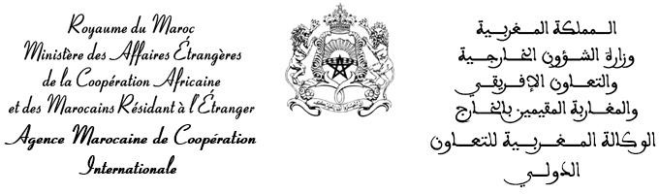

Application form for training in Morocco Academic year 2022/2023

- Downloadable from the AMCI website (link: https://www. amci.ma/publications)
- All fields must be completed.

Check the box corresponding to the requested cycle

Photo
Bachelor’s degree Master’s degree Doctorate Medical specialty Others (to be specified) : ....................................................................................

Have you ever received a training in Morocco: Yes No
2-1. If yes check the sector: Public Private
    - If Public
      - AMCI registration # : ......................................................................
      - City : ...............................................................................................
      - Institution : ......................................................................................
Did you obtain a diploma: Yes No

If yes :
- Obtained diploma : ..................................................................
- Graduation year :.....................................................................

Identity : (as shown in your ID)
3-1. Type of ID : Passport Others : .................................................................................................
3-2. Id number: ......................................................................................................................................
3-3. First name :......................................................................................................................................
3-4. Last name :.....................................................................................................................................
3-5. Gender :...........................................................................................................................................
3-6. Maiden name:..................................................................................................................................
3-7. Date of birth (D/M/Y :......................................................................................................................
3-8. Country of birth : ............................................................................................................................
3-9. City of birth : ..................................................................................................................................
3-10. Nationality (Country): ....................................................................................................................

Contact information:
4-1. Residence country :.........................................................................................................................
4-2. City: ................................................................................................................................................
4-3. Zip code: .........................................................................................................................................
4-4. Mailing address: .............................................................................................................................
......................................................................................................................................................
4-5. Email address (E-mail) : .................................................................................................................
4-6. Phone (including indicative) : .........................................................................................................

Filiations:
5-1. Last and First name of father : .......................................................................................................
5-2. Function: .........................................................................................................................................
5-3. Last and First name of mother: ......................................................................................................
5-4. Function: .........................................................................................................................................
5-5. Last and First name of guardian: ....................................................................................................
5-6. Function: .........................................................................................................................................

Training courses followed:
6-1. Candidates for post-high school studies

a- Obtained Marks in final class  (for candidates preparing the high school diploma or similar) | Obtained marks
Basic subjects | 1st term | 2nd term | 3rd term
Average of term

b- For candidates titular a high school diploma or similar |  |  | Obtained marks at the  final year of high school or similar
Basic subjects | Coefficients | Obtained marks at the high school  diploma/20 | 1st term | 2nd term | 3rd term
Average of basic subjects
Overall average of the high school diploma or similar

6-2. Candidates for post high school studies

Obtained diploma | Specialty/ Serie | Session | Year | General average | Distinction | Place of graduation
- Training requested (by order of preference):

Institutions | Branches | Cities | Degrees to prepare

Do you accept a different orientation if it is offered to you? Yes No
- The application file must include the following documents:
  - The following application form duly completed;
  - 02 authenticated photocopies of the diploma or certificate of successful completion of the High School Diploma. Candidates submitting certificates of success, must produce their diplomas to their institutions, at the latest, during the 2nd year of training;
  - 02 authenticated photocopies of the marks transcript of the High School Diploma;
  - 02 extracts of birth certificate;
  - 02 photocopies of the passport (if available);
  - A recent criminal record;
  - A medical certificate issued by the public health services attesting to the physical fitness of the candidate and certifying that he / she is vaccinated and is not suffering from any contagious or acute disease, or carrying a pandemic including tuberculosis. The candidate may be subject to a counter-visit upon his / her arrival in Morocco;
  - 02 recent identity photos, in color, with the name, first name (s) and nationality of the applicant on the back;
  - Candidates for the Master's degree or Doctorate's degree must provide, in addition to the aforementioned documents, certified copies of their higher education diplomas, marks transcripts and curricula, as well as a dissertation / thesis copy of end of studies / doctoral thesis project.
N.B : Incomplete files will not be considered.

